**Unit 1**

**Introduction to Data Communication**

**Introduction to Data Communication**

Data communication refers to the process of exchanging digital information between two or more devices using a transmission medium, such as cables, optical fibers, or wireless signals. It enables the transfer of data in the form of text, audio, video, or other formats, adhering to predefined rules (protocols) to ensure accurate and efficient delivery. Modern data communication systems form the backbone of computer networks, including the internet, by facilitating seamless interaction between devices across local and global scales.

**Key Elements/Components of Data Communication**

A data communication system comprises five fundamental components:

1. **Message**: The actual data or information to be transmitted. This could be a text file, an image, a video stream, or a database query.
2. **Sender (Transmitter)**: The device or system that initiates the transmission. Examples include computers, smartphones, servers, or IoT devices. The sender converts the message into a signal suitable for the transmission medium.
3. **Receiver**: The destination device that accepts the transmitted message. It decodes the signal back into usable data (e.g., a printer receiving a document or a browser rendering a webpage).
4. **Transmission Medium**: The physical or wireless channel through which the message travels. Common media include twisted-pair cables, coaxial cables, fiber optics, radio waves, or infrared signals.
5. **Protocols**: A set of rules governing data communication. Protocols define how devices identify each other, establish connections, format data, handle errors, and terminate communication. Examples include TCP/IP, HTTP, and Ethernet standards.

**Data Communication Models**

Two primary models structure modern data communication:

* **OSI Model (Open Systems Interconnection)**
* **TCP/IP**

**Data Transmission**

Data transmission is the process of sending and receiving data between devices, using different mediums like cables, optical fibers, or wireless signals.

**Analog vs. Digital:**

**Analog Transmission** refers to the continuous transfer of data using signals that vary in amplitude, frequency, or phase over time. These signals are sensitive to noise and distortion during transmission, which can degrade quality. Examples include traditional telephone systems and radio waves. Analog signals are ideal for conveying real-world phenomena like sound or temperature.

**Digital Transmission** involves discrete signals represented by binary values (0s and 1s). These signals are less prone to noise and can be regenerated accurately at intermediate nodes. Digital transmission is the backbone of modern networks (e.g., Ethernet, Wi-Fi) due to its efficiency in error detection/correction and compatibility with computing systems. A key challenge is synchronization between sender and receiver to interpret bit timing correctly.

**Transmission Media**

A transmission medium is a physical path between the transmitter and the receiver i.e. it is the channel through which data is sent from one device to another. Transmission Media is broadly classified into the following types:

**Guided (Wired) Media**:

Guided Media is also referred to as Wired or Bounded transmission media. Signals being transmitted are directed and confined in a narrow pathway by using physical links.

1. **Twisted Pair Cable**
   * Looks like a pair of **copper wires twisted together**.
   * The twists help reduce interference (like unwanted noise in a phone call).
   * Used in **Ethernet (LAN cables) and telephone lines**.
   * Two types:
     + **UTP (Unshielded Twisted Pair):** Cheaper but more prone to interference.
     + **STP (Shielded Twisted Pair):** Has extra shielding for better protection.
2. **Coaxial Cable**
   * Has a **central copper wire**, surrounded by layers of insulation and a metallic shield with an outer jacket.
   * **Better at blocking interference** than twisted pair cables.
   * Provides higher Bandwidth.
   * Used for **cable TV, broadband internet, and older networks**.
3. **Fiber-Optic Cable**
   * Uses **light** instead of electricity to send data.
   * Made of **thin glass or plastic fibers**.
   * **Super-fast and can carry signals over long distances** (e.g., undersea internet cables).
   * Immune to electrical interference, making it **ideal for high-speed internet and backbone networks**.

**Unguided (Wireless) Media**:

It is also referred to as Wireless or Unbounded transmission media. No physical medium is required for the transmission of electromagnetic signals.

* **Radio Waves**: Long-wavelength signals used for Wi-Fi, AM/FM radio, and Bluetooth. They can travel **in all directions**, making them great for **broad coverage** (e.g., radio stations covering an entire city).
* **Microwaves**: Short-wavelength signals requiring a **clear line of sight** between sender and receiver (like how satellite dishes must point at the sky). Used in satellite communication, cellular networks, and point-to-point links.
* **Infrared**: Short-range communication (e.g., TV remotes, IrDA). Limited by obstacles and interference from light sources.

**Synchronous vs. Asynchronous Data Transmission**

**Synchronous Transmission**:

**Synchronous Transmission** means that data is sent in **large blocks (frames)**, and both the sender and receiver must be **perfectly timed**. This requires their clocks to be synchronized, either through a separate timing signal or embedded clock bits. Because of this precise timing, **synchronous transmission is best for high-speed, continuous data transfer**, such as **video streaming and large file transfers**. An example of this is **HDLC (High-Level Data Link Control),** which uses special synchronization bits to organize the data into frames.

**Asynchronous Transmission**:

**Asynchronous Transmission**, on the other hand, sends **small, separate units** (like individual characters or bytes). Each unit of data has a **start and stop bit** to indicate when it begins and ends, so there’s **no need for a shared clock** between sender and receiver. This makes asynchronous transmission **useful for occasional data transfers**, such as **keyboard input or messaging apps**. A common example is the **RS-232 serial communication standard**, used in older computer connections.

**Line Configuration (Types of Communication Channels)**

1. **Simplex** – This is **one-way communication** where data flows in only one direction. One device **always sends**, and the other **only receives**.
   * **Example:** A **keyboard** sends input to a computer, but the computer doesn’t send data back to the keyboard. Similarly, **radio broadcasts** only transmit signals to listeners.
2. **Half-Duplex** – Here, communication is **two-way**, but **only one device can send data at a time**. Devices **take turns** to send and receive.
   * **Example:** A **walkie-talkie**, where one person speaks while the other listens, and they switch roles. Another example is **traditional Ethernet (CSMA/CD)**, where devices wait for their turn to send data.
3. **Full-Duplex (Duplex)** – In this type, **both devices can send and receive data at the same time**. This is possible by using **separate channels** for transmission and reception or special signal-sharing techniques.
   * **Example:** **Telephone networks**, where you can talk and listen at the same time. Also, **modern Ethernet** supports full-duplex communication for high-speed data transfer.

**Network Topologies**

Network topology defines the physical or logical arrangement of devices (nodes) and communication links in a network. The choice of topology impacts performance, scalability, fault tolerance, and cost. The four primary topologies are **Star**, **Bus**, **Ring**, and **Mesh**, each with distinct characteristics and use cases.

**1. Star Topology**

In Start Topology, all devices are connected to a central hub or switch. The hub acts as a mediator for all communication. Here, devices communicate through the central hub. For example, if Device A sends data to Device B, the hub receives the signal and forwards it to the destination.

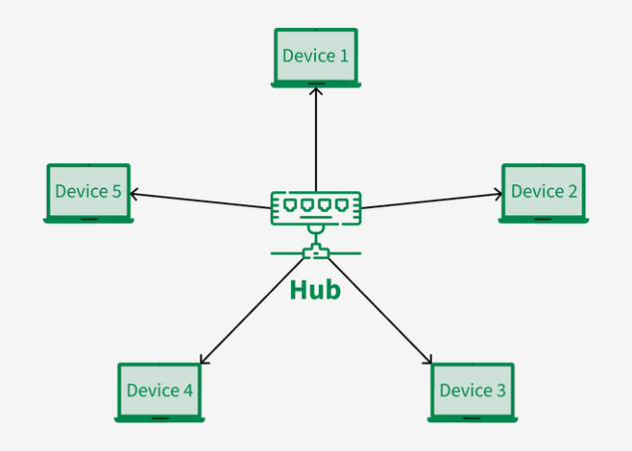

* **Advantages**:
  + Easy to install, manage, and troubleshoot (centralized control).
  + Failure of a single node does not affect the rest of the network.
  + Scalable—new devices can be added without disrupting the network.
* **Disadvantages**:
  + The central hub is a single point of failure. If it fails, the entire network collapses.
  + Higher cost due to the need for a central hub and cabling.
* **Examples**: Modern Ethernet LANs using switches, Wi-Fi networks with a central router.

**2. Bus Topology**

In this approach, all devices share a single communication line (bus) acting as a backbone. Devices tap into the bus using drop lines or connectors. Here, data sent by a device is broadcast to all nodes on the bus. Therefore, only the intended recipient processes the data (based on MAC addresses). Terminators at the bus ends absorb signals to prevent reflection.

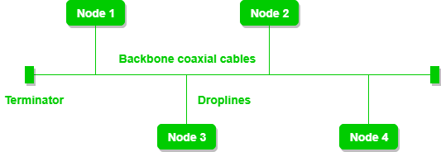

* **Advantages**:
  + Simple and inexpensive to set up (minimal cabling).
  + Suitable for small networks.
* **Disadvantages**:
  + **Collisions**: If two devices transmit simultaneously, signals collide, corrupting data. It requires protocols like **CSMA/CD** (Carrier Sense Multiple Access with Collision Detection) to avoid this issue.
  + Limited scalability—performance degrades as more devices are added.
  + A break in the bus cable disrupts the entire network.
* **Examples**: Legacy Ethernet networks (10Base2, 10Base5).

**3. Ring Topology**

In Ring Topology, devices are connected in a closed loop, where each node is linked to exactly two others. The data travels in one direction (unidirectional) or both (bidirectional). Here the data transmission is done through **Token Passing**. A token (a special frame) circulates the ring, and a device must hold the token to transmit data, preventing collisions.

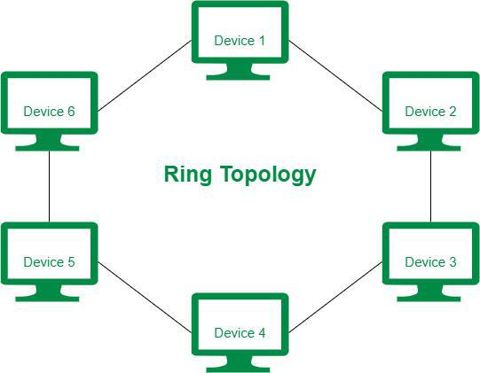

* Example: In **Token Ring** networks, a device captures the token, attaches its data, and releases the token after transmission.
* **Advantages**:
  + No collisions due to token-based access.
  + Predictable performance (equal access for all nodes).
* **Disadvantages**:
  + A single node or cable failure can break the entire ring.
  + Complex to reconfigure (adding/removing nodes disrupts the ring).
  + Latency increases with mor e nodes (data must traverse all intermediate nodes).
* **Examples**: IBM Token Ring (IEEE 802.5), Fiber Distributed Data Interface (FDDI).

**4. Mesh Topology**

Every device is interconnected with every other device, creating multiple redundant paths. Here the data can take any available path to the destination. The Routing algorithms (e.g., OSPF, BGP) determine the optimal path.

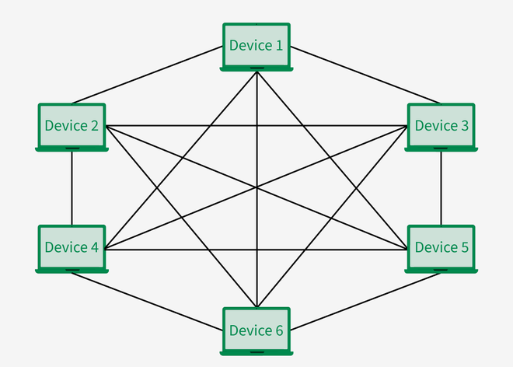

* + **Full Mesh**: Each node connects to all other nodes (N(N-1)/2 links for N nodes).
  + **Partial Mesh**: Critical nodes have multiple connections, while others connect to a few.
* **Advantages**:
  + High redundancy and fault tolerance—if one link fails, traffic reroutes.
  + High performance (no congestion due to multiple paths).
* **Disadvantages**:
  + Extremely high cost (cabling and hardware for numerous links).
  + Complex to configure and manage.
* **Examples**: Internet backbone networks, military communication systems.

**Computer Networks: Definition and Uses**

A **computer network** is a collection of interconnected devices (nodes) that communicate and share resources using standardized protocols. Networks enable efficient data transfer, resource sharing (e.g., printers, storage), and collaborative applications.

**Key Uses**:

* **Resource Sharing**: Centralized servers provide shared access to files, databases, or hardware (e.g., cloud storage, network printers).
* **Communication**: Email, instant messaging, video conferencing, and social media rely on network connectivity.
* **Distributed Computing**: Tasks are split across multiple devices (e.g., cloud computing, blockchain).
* **Internet Access**: Global connectivity for web browsing, streaming, and e-commerce.

**Network Hardware**

Network hardware comprises the physical devices and components that enable communication:

1. **Network Interface Card (NIC)**:
   * It is a tool that connects a device (e.g., PC, server) to the network. It converts data into electrical/optical signals for transmission.
   * Example: Ethernet card, Wi-Fi adapter.
2. **Switches**:
   * These are **Layer 2 (Data Link Layer)** devices that forward frames to specific devices using MAC addresses.
   * It reduces collisions by creating dedicated paths between sender and receiver (unlike hubs).
3. **Routers**:
   * Routers are **Layer 3 (Network Layer)** devices that route packets between different networks using IP addresses.
   * Connect LANs to WANs (e.g., home router linking a LAN to the internet).
4. **Access Points (APs)**:
   * Enable wireless devices to connect to a wired network (e.g., Wi-Fi routers).
5. **Modems**:
   * Convert digital signals to analog for transmission over telephone lines (e.g., DSL modems).

**Network Structures:**

**1. Point-to-Point Connection**

* A **direct, private link** between **two devices** (like a private phone call between two people).
* **Key Features**:
  + Only those two devices use the connection—no one else can share it.
  + Used for long-distance setups, like connecting offices in different cities with a dedicated cable or satellite link.
  + Common in large networks (e.g., linking two routers over the internet).
* **Example**: Your computer connecting to the internet through an old-school dial-up modem.

**2. Multicast**

* Sending data to **a specific group of devices** (like a group text message where only selected people receive it).
* **Key Features**:
  + Saves bandwidth by sending data only to devices that need it (e.g., live sports streaming to fans watching the game).
  + Uses a protocol called **IGMP** to keep track of which devices are part of the group.
  + Routers help by copying the data only where needed, reducing unnecessary traffic.
* **Example**: A Zoom meeting where only invited participants get the video feed.

**3. Broadcast**

* Sending data to **every device on the network** (like a loudspeaker announcement in a building).
* **Key Features**:
  + Used for important network tasks, like assigning IP addresses or finding devices (e.g., "Who has this IP address?").
  + Can clutter the network in large setups because everyone gets the message, even if they don’t need it.
  + Limited to small areas, like a single office network (not the whole internet).
* **Example**: When your laptop automatically gets an IP address from the Wi-Fi router.

**Classification of Networks: LAN, WAN, and MAN**

**1. Local Area Network (LAN)**

A **Local Area Network (LAN)** is designed to connect devices within a limited geographic area, such as a single building, office, or campus. These networks are typically owned, managed, and operated by a single organization, ensuring high-speed communication with minimal delays. LANs use guided transmission media like twisted-pair cables or fiber optics, and wireless technologies like Wi-Fi (IEEE 802.11). Key characteristics include:

* **High Data Rates**: LANs support speeds ranging from 100 Mbps (Ethernet) to 10 Gbps (modern fiber-based networks).
* **Low Latency**: Due to the short distances, data transmission delays are negligible.
* **Topologies**: Common layouts include star (with a central switch) or bus (legacy Ethernet).
* **Protocols**: Ethernet (IEEE 802.3) dominates wired LANs, while Wi-Fi (IEEE 802.11) is standard for wireless LANs.
* **Use Cases**: File sharing, printer access, and internal communication within organizations.

**Example**: A university’s computer lab where all PCs share resources via a central server.

**2. Wide Area Network (WAN)**

A **Wide Area Network (WAN)** spans large geographic regions, such as countries or continents, and connects multiple LANs or smaller networks. Unlike LANs, WANs rely on public or leased infrastructure (e.g., telephone lines, satellites) and are not owned by a single entity. Internet Service Providers (ISPs) and telecom companies manage the infrastructure. Key features include:

* **Global Reach**: WANs enable communication between devices thousands of kilometers apart.
* **Heterogeneous Infrastructure**: Combines fiber optics, microwave links, and cellular networks.
* **Routing**: Uses complex protocols like **TCP/IP** and **BGP (Border Gateway Protocol)** to route data across multiple hops.
* **Lower Speeds**: Compared to LANs, WANs have lower data rates due to longer distances and shared infrastructure.
* **Cost**: High operational costs due to leased lines and third-party services.

**Example**: The internet itself is the largest WAN, connecting billions of devices worldwide.

**3. Metropolitan Area Network (MAN)**

A **Metropolitan Area Network (MAN)** covers a city or metropolitan area, bridging the gap between LANs and WANs. MANs are often operated by municipal authorities or large organizations to interconnect multiple LANs within a city. Key aspects include:

* **Moderate Coverage**: Typically spans 5–50 km (e.g., a university campus network across a city).
* **High-Capacity Links**: Uses fiber optics or wireless technologies like microwave transmission for fast data transfer.
* **Shared Infrastructure**: Resources like regional servers or cloud services are accessible to all connected LANs.
* **Applications**: Used by ISPs to provide city-wide broadband, or by governments for public safety networks.

**Example**: A city-wide network linking all public libraries, allowing residents to access centralized databases.

**Network Software: Protocol Hierarchies, Design Issues, and Services**

**Protocol Hierarchies**

A **protocol hierarchy** (or *layered architecture*) organizes network functionality into distinct layers, each responsible for specific tasks. Layers interact through well-defined interfaces, enabling modular design and simplifying complexity. This approach ensures interoperability, as each layer relies on services from the layer below and provides services to the layer above.

**Key Concepts**:

* **Protocol**: A set of rules governing communication between entities at the same layer (e.g., HTTP at the application layer).
* **Interface**: Defines how adjacent layers exchange information (e.g., a transport layer passing data to the network layer).
* **Service**: The functionality a layer offers to the layer above it (e.g., error detection by the data link layer).

**Example**: The **OSI Model** (7 layers) and **TCP/IP Model** (4 layers) are classic examples of protocol hierarchies.

**Design Issues for Layers**

Common challenges addressed across layers in a protocol stack include:

1. **Addressing**:
   * Identifying senders and receivers (e.g., MAC addresses at the data link layer, IP addresses at the network layer).
2. **Error Control**:
   * Detecting and correcting corrupted data (e.g., CRC checks in the data link layer, TCP retransmissions at the transport layer).
3. **Flow Control**:
   * Managing data rates to prevent overwhelming the receiver (e.g., sliding window protocol in TCP).
4. **Multiplexing**:
   * Combining multiple data streams into one channel (e.g., multiplexing VoIP and web traffic over a single connection).
5. **Routing**:
   * Determining optimal paths for data (e.g., OSPF at the network layer).
6. **Security**:
   * Ensuring confidentiality and integrity (e.g., TLS encryption at the application layer).

**Interfaces and Services**

**Interfaces**

An interface defines how layers communicate vertically:

* **Service Access Point (SAP)**: The point where a layer provides services to the layer above (e.g., sockets at the transport layer).
* **Primitives**: Operations like *request*, *indication*, *response*, and *confirm* that formalize service interactions.

**Example**: The network layer (IP) provides a *send packet* service to the transport layer (TCP) through an interface.

**Services**

Services are categorized based on their communication style:

1. **Connection-Oriented Service**:
   * **Definition**: Requires establishing a dedicated connection before data transfer, similar to a phone call.
   * **Features**:
     + Reliable, ordered delivery (e.g., TCP).
     + Includes setup (handshake) and teardown phases.
     + Guarantees error-free transmission through acknowledgments and retransmissions.
   * **Use Case**: File transfers, web browsing.
2. **Connectionless Service**:
   * **Definition**: Data is sent without prior setup, like mailing a letter.
   * **Features**:
     + No guarantees of delivery, order, or error correction (e.g., UDP).
     + Lower overhead and faster transmission.
   * **Use Case**: Real-time streaming (video calls), DNS queries.